About ACG Join Donate Store Find a GI My ACG/Log In

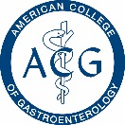

Membership Education Clinical Guidelines Publications **Trainees** Patients & Families

Membership Resources Fellowship Program Program Director

Information Resources

**Headshot**

“Quote quote quote quote quote

quote quote quote quote quote”

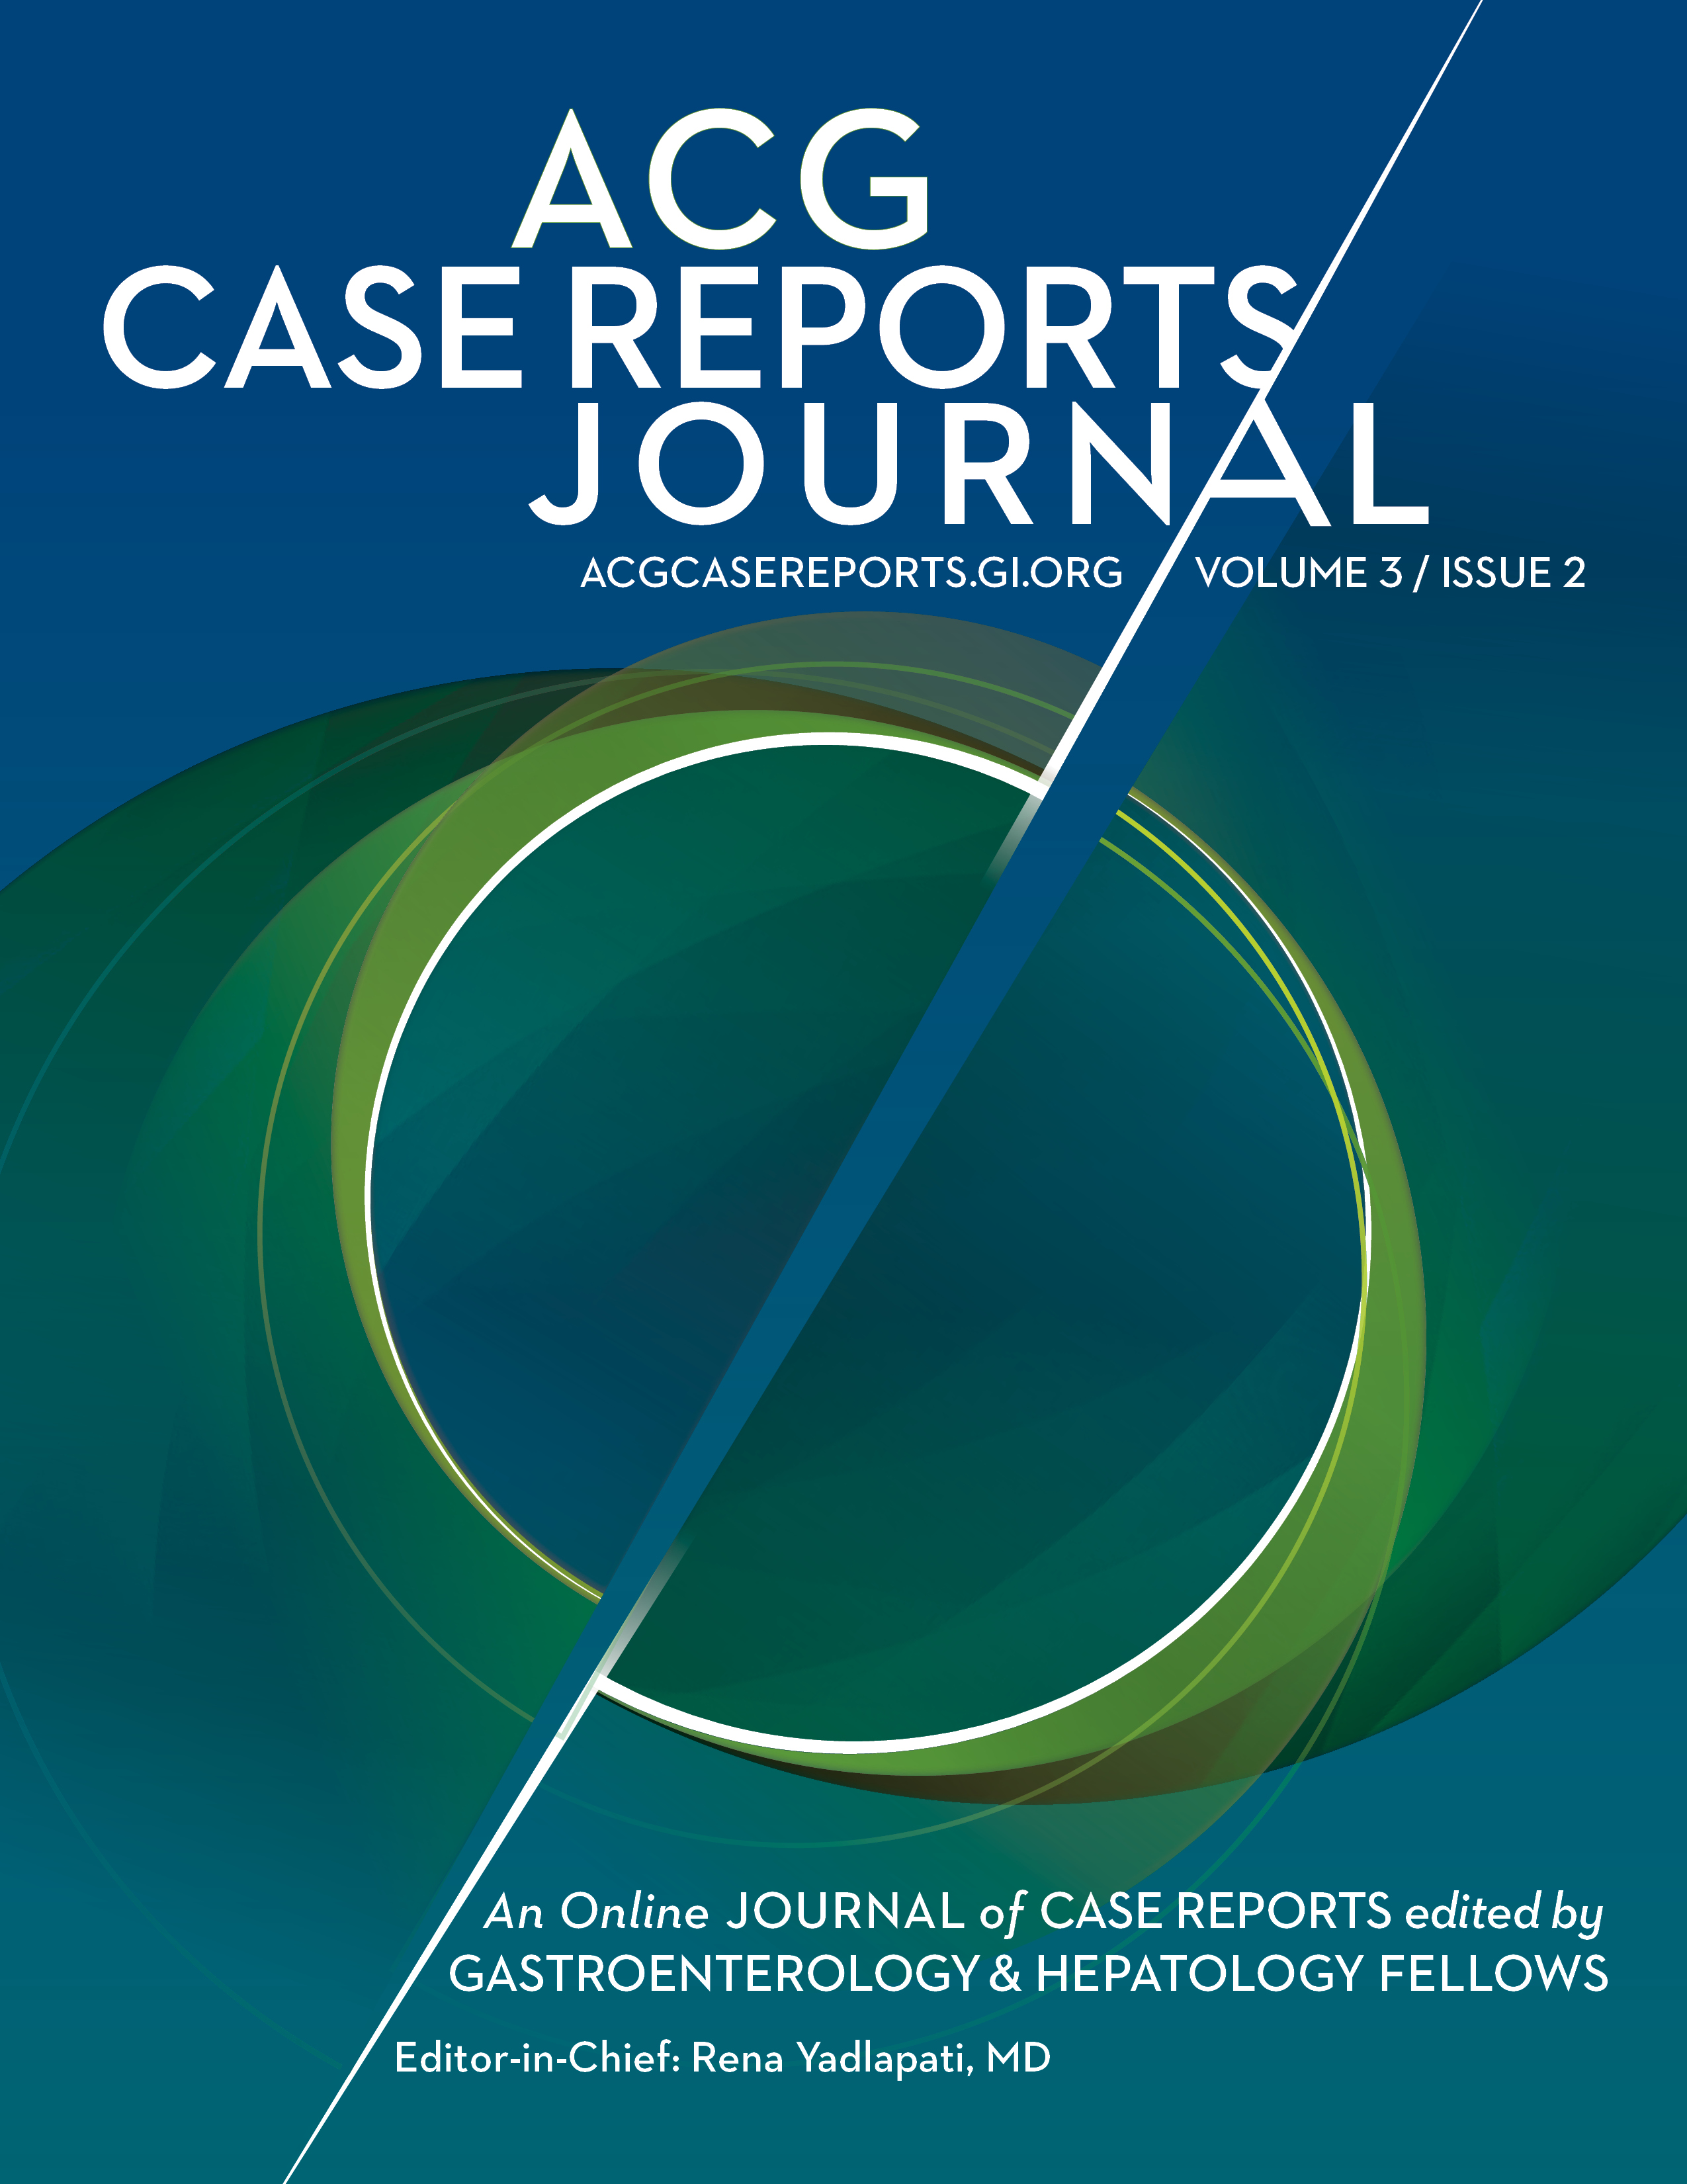

*Case Reports Journal*



Mentoring and Career Resources



Board Review Question of the Week:

Week Starting 2/5/2018

A 53 year old man presents with ascites. He has a history of chronic hepatitis B, and a liver biopsy 5 years ago showed bridging fibrosis. He has never been treated for hepatitis B. The physical exam…MORE

**Trainee Meeting Calendar Widget**

**January 18 – 20, 2019**: 2nd Year Fellows Course

**March 2019**: North American Conference of GI Fellows

**October 2019**: Navigating, Networking and Negotiating Your 1st Job Workshop

**October 2019**: Trainees Lunch



* Clinical Research Grants
* FDA Visiting Fellowship
* International Training Grant



Rotating Topic:

Finance 101 Webinar

Program Director Resources

* Ed Universe Training Pathway
* OSCE Toolkit
* EPAs

Contact Us:

Name: 

Email:

Message: 